GROUP 1
SUPPLY AND FACILITY INVENTORY
MANAGEMENT SYSTEM
In partial fulfillment of the requirements in
SOFTWARE ENGINEERING 1
Leader: Wagwag, Byron Scott G.
Members:
Bondame, Sean Allen G.
Dela Cruz, Charisse F.
Husain, Stephan Yder
Requirements Gathering
Sources:
* Self-study
* Online research
Hardware Requirements
* RAM: Minimum 8GB (for smooth performance of the system, particularly with large datasets) * Processor: Intel i5 or higher (for quick processing of requests)
* Storage: 500GB SSD (for fast data retrieval and system responsiveness)
* Network: Reliable internet connection (for cloud-based or multi-user environments) * Backup Power: UPS (to prevent data loss due to power failures)
Software Requirements
Features to be included in your system
(Module 1) Registration & Login
Functions:
Registration Restrictions
1. Admin Approval for New Accounts
* Only accounts approved by an administrator can access the system.
2. Role-Based Access Control (RBAC)
* Users are assigned specific roles (Admin, Staff, Viewer) with limited access based on their responsibilities. 3. Duplicate Registration Prevention
* The system checks for existing accounts using email, employee ID, or national ID to block duplicates.
Login Validation
1. Password Verification
* User-entered passwords are compared with securely hashed passwords stored in the database using industry-standard algorithms (e.g., bcrypt, Argon2).
2. Account Status Check
* The system verifies if the user’s account is active and approved by an admin before allowing access.
3. Login Attempt Limiting
* Limits the number of failed login attempts to prevent brute-force attacks.
4. Two-Factor Authentication (Optional/Advanced)
* Adds an extra layer of security by requiring a code sent to the user’s registered email or phone.
INTRODUCTION
Background
The current inventory and facility management process at Pamantasan ng Lungsod ng Muntinlupa (PLMun) is primarily manual, relying on handwritten records and spreadsheets to track supplies, equipment, and facility usage. This traditional approach often leads to inefficiencies, inaccurate data, and mismanagement of resources.
Common problems include difficulties in tracking supply availability, delayed request approvals, loss of records, and lack of real time visibility on facility usage. These inefficiencies impact not only administrative operations but also the timely delivery of resources to students and faculty.
To address these challenges, the implementation of a Supply and Facility Inventory Management System is proposed. The system will automate the recording, tracking, and management of university supplies and facilities, improving accuracy, transparency, and efficiency in PLMun’s operational processes.
Purpose
The purpose of this project is to enhance the management of supplies and facilities at PLMun by replacing the manual tracking system with an automated, centralized, and user-friendly web-based solution.
The system aims to:
· Digitize inventory management and facility scheduling
· Enable real-time monitoring of supply availability and usage
· Reduce administrative workload and human error
· Improve accountability and transparency in resource allocation
This solution will benefit both administrative and academic departments by ensuring smooth, accurate, and timely handling of supply and facility-related operations.
Scope
System Features
The proposed system will include the following core functions:
· Supply Management: Add, update, monitor, and categorize supply stocks and items.
· Facility Management: Manage facility booking, availability, and maintenance records.
· Request and Approval Workflow: Allow faculty or staff to request supplies or facilities for events, classes, or maintenance activities.
· Real-Time Reporting: Generate automated reports on inventory levels, usage frequency, and facility reservations. Integration and Access
· The system will be integrated into PLMun’s internal network for secure access.
· A centralized database will manage real-time updates on supplies and facilities.
· Role-based user access will ensure proper authorization for administrators, staff, and department heads.
Stakeholders
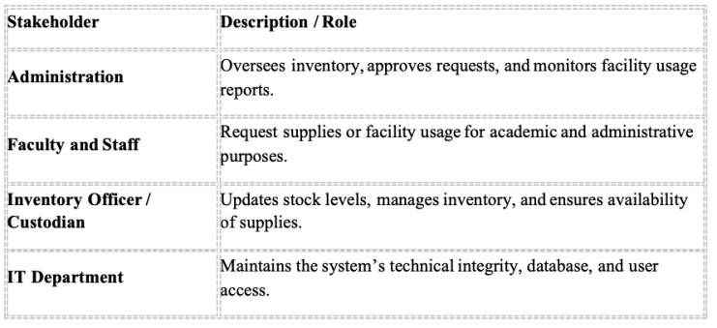
PROBLEM STATEMENT
Current Situation
At present, PLMun’s supply and facility management relies on manual processes such as written logs, spreadsheets, and physical documents. This leads to:
· Delayed updates and inaccurate inventory data
· Difficulty in tracking facility usage and availability
· Loss or duplication of records
· Time-consuming approval processes
· Lack of a centralized database for inventory and facility records
The proposed system seeks to address these challenges through automation, improving operational efficiency and data reliability.
Impact Analysis
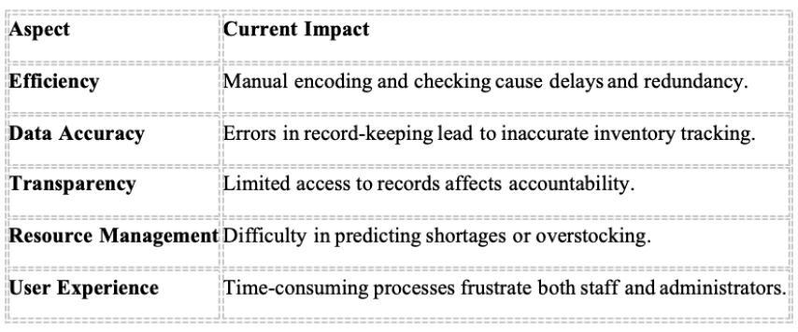
Justification
The development of the Supply and Facility
Inventory Management System is necessary to:
· Improve inventory accuracy and minimize loss
of resources.
· Increase efficiency through automated tracking
and reporting.
· Enhance security and accountability by
monitoring user activities.
· Provide data-driven insights for better
decision-making and budgeting.
PROPOSED SOLUTION
Alternative Approaches
1. Spreadsheet-Based Tracking
o Uses Excel or Google Sheets to record supply and facility information.
2. RFID-Based Inventory System
o Uses RFID tags to automate stock tracking and movement.
3. Web-Based Supply and Facility Management System
o A centralized system where users can log in to manage supplies, facilities, and reports.
Pros and Cons
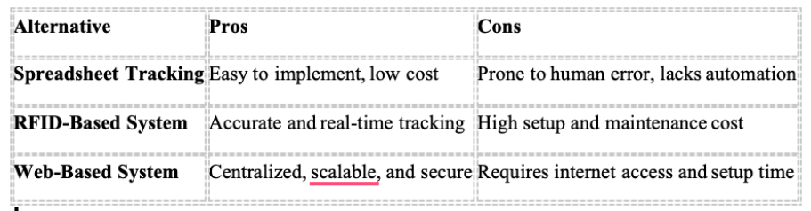
Recommended Solution
The recommended approach is to implement a Web-Based Supply and Facility Inventory Management System, as it offers a balanced combination of efficiency, scalability, security, and affordability. The system will centralize all records, automate tracking, and provide analytical reporting tools to improve decision-making.
REQUIREMENTS GATHERING
Sources
· Self-Study: Analysis of existing PLMun inventory and facility management processes. · Online Research: Study of best practices and modern system architectures for inventory management solutions.
Hardware Requirements
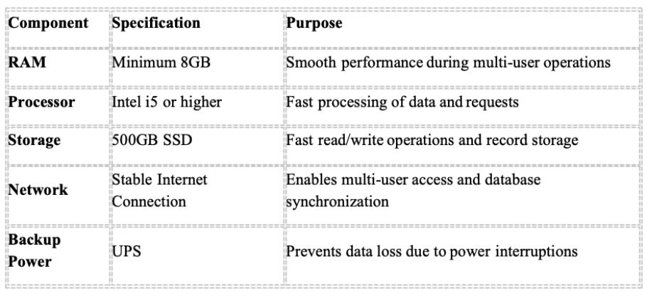
Software Requirements
5. SYSTEM FEATURES
Registration & Login
Functions:
Registration Restrictions
1. Admin Approval for New Accounts
Only administrator-approved users can access the system.
2. Role-Based Access Control (RBAC)
Assigns access rights to Admin, Staff, and Viewer roles.
3. Duplicate Registration Prevention
Prevents duplicate user accounts through ID or email validation. Login Validation
1. Password Verification using secure hashing algorithms (bcrypt or Argon2). 2. Account Status Check ensures that only active accounts can log in. 3. Login Attempt Limiting to prevent brute-force attacks.
4. Two-Factor Authentication (Optional) via email or SMS for enhanced security.
Supply Management
· Add, edit, and delete supply items.
· Set thresholds for minimum stock levels.
· Generate automatic alerts when supplies are low.
· Track issuance and return of supplies.
· Generate inventory reports.
Facility Management
· Schedule and manage facility usage.
· Prevent double-booking conflicts.
· Record facility maintenance history.
· Generate facility utilization reports.
Request & Approval Workflow
· Faculty or staff can submit supply or facility requests.
· Admin reviews and approves or denies requests.
· Automatic email or dashboard notifications for updates.
Reporting and Analytics
· Generate monthly and annual inventory summaries.
· Visual dashboards for supply and facility usage trends.
· Export reports in PDF, Excel, or CSV format.
SECURITY & DATA PRIVACY
· All data (including user credentials) will be encrypted during storage and transmission. · Access logs will record all user actions for transparency.
· Complies with Data Privacy Act of 2012 for user and institutional data protection.
SYSTEM PLANNING OUTLINE
INTRODUCTION
Project Description
The Supply and Facility Inventory Management System is a proposed digital solution designed for Pamantasan ng Lungsod ng Muntinlupa (PLMun) to efficiently manage the university’s supplies and facilities.
Currently, inventory tracking and facility management are handled manually through logbooks and paper-based requests, which often result in delays, data inaccuracies, and stock shortages.
This system aims to automate supply requests, inventory updates, and facility monitoring through a secure, centralized web-based platform—enhancing transparency, efficiency, and accountability across departments.
Objectives and Purpose of the System
The purpose of the Supply and Facility Inventory Management System is to streamline the processes of supply distribution and facility utilization at PLMun. Specifically, it aims to:
· Digitize and automate supply and facility request procedures.
· Provide real-time tracking of inventory levels and facility usage.
· Reduce human error and administrative workload.
· Improve accountability through digital reports and audit trails.
· Support informed decision-making via analytics and reporting tools.
Scope of the System
The system will include the following features:
· Supply Inventory Management: Real-time tracking of supply levels, item issuance, and restocking alerts. · Facility Management: Monitoring of room and equipment availability.
· Request Management: Online submission and approval of requests for supplies and facilities.
· User Management: Role-based access for admin, supply staff, and faculty members. · Reports and Analytics: Automated report generation for usage and stock statistics.
Excluded from scope:
· Integration with external ERP or financial systems (optional future enhancement). · Handling of external supplier transactions outside PLMun’s internal inventory.
Stakeholders Involved
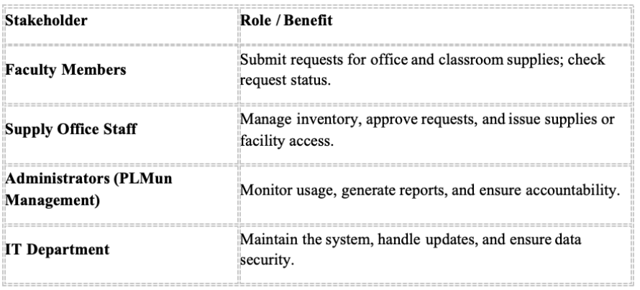
FEASIBILITY STUDY
The Supply and Facility Inventory Management System aims to automate and streamline the process of managing office and school supplies within an institution. Currently, supply offices often rely on manual or semi-digital methods, resulting in inefficiencies such as inaccurate tracking, delays in request approvals, and stock shortages. This system seeks to address these issues by providing an online platform for faculty to submit requests, supply staff to manage stock, and administrators to oversee reports and trends.
OBJECTIVES OF THE STUDY
- To develop an automated system that tracks supply requests, approvals, and inventory levels in real time. - To improve transparency and accountability in supply distribution.
- To generate automated reports for administrative monitoring.
- To reduce manual paperwork and human errors in the supply management process.
SCOPE OF THE SYSTEM
- The system covers the following functionalities:
- Registration & Login: Secure faculty registration and admin-approved accounts.
- Request Module: Faculty can send supply requests that are filtered and prioritized.
- Inventory Module: Supply staff can manage stock levels, add/edit items, and receive low-stock alerts. - Reports Module: Admins can generate reports on item usage, department consumption, and shortages. - Users include faculty members, supply office staff, and university administrators.
OPERATIONAL FEASIBILITY
- The proposed system will simplify and improve current operations by:
- Allowing faculty to submit and track supply requests online.
- Providing supply staff with a centralized dashboard to approve or deny requests and update stock. - Automatically alerting users of low inventory levels to prevent shortages.
- Giving administrators a data-driven view of supply usage for better planning.
- Since the system aligns with existing workflows but replaces manual processes with automation, it is highly operationally feasible.
TECHNICAL FEASIBILITY
Hardware Requirements:
Server/PC: Minimum Intel i5 processor or higher.
RAM: 8GB for server; 4GB for client.
Storage: 250GB SSD for server; 500GB for backup.
Network: Stable LAN or cloud-based connectivity.
Barcode/QR Scanner: For quick inventory updates.
Software Requirements:
Operating System: Windows Server or Linux (Ubuntu).
Database: MySQL or PostgreSQL.
Back-End: Node.js with Express or Laravel (PHP).
Front-End: React.js (Responsive UI).
Version Control: GitHub/GitLab.
Cloud Hosting (Optional): AWS EC2 or Google Cloud.
Economic Feasibility
Estimated Costs
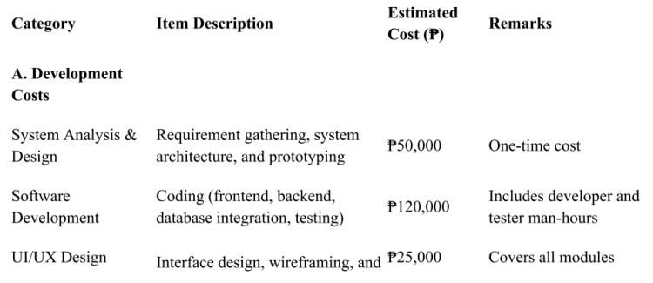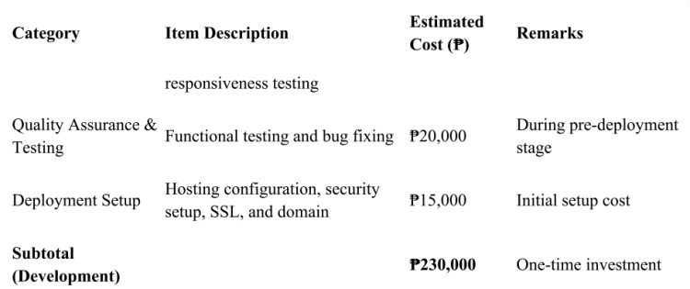
B. Hardware & Equipment Costs
Server or Cloud Hosting | Dedicated VPS (100 concurrent users) | ₱12,000 / year | e.g., DigitalOcean or AWS Workstations (3 units) | For supply staff and admin | ₱90,000 | ₱30,000 each |
Barcode/QR Scanners (3 units) | For fast supply issuance | ₱12,000 | ₱4,000 each |
Printers (2 units) | For receipts and reports | ₱10,000 | ₱5,000 each || UPS (Uninterruptible Power Supply) | For data loss prevention | ₱6,000 | One-time cost |
Network Equipment | Routers, LAN cables, and modems | ₱8,000 | One-time setup |
Subtotal (Hardware) | | ₱138,000 | One-time + minor recurring |
C. Operational & Maintenance Costs
Web Hosting Renewal | Annual hosting and domain renewal | ₱12,000 / year | Recurring |
System Maintenance | Monthly updates, bug fixes, monitoring | ₱30,000 / year | IT support cost | Data Backup & Storage | Cloud backups and redundancy | ₱6,000 / year | Optional |
User Training | Initial training for 100 users | ₱15,000 | One-time workshop |
Technical Support | Hotline or ticket-based support | ₱10,000 / year | Maintenance phase |
Subtotal (Operational) | | ₱73,000 / year | Recurring annual cost |
D. Contingency & Miscellaneous Costs
Contingency Fund (10%) | For unforeseen expenses | ₱23,000 | Standard contingency |
TOTAL PROJECT COST (Initial Year) | | ₱464,000 | Including development & hardware |
Expected Benefits
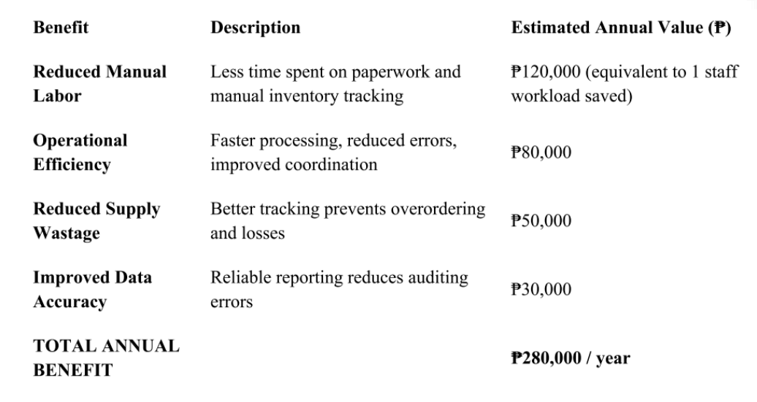
Funding Sources
· PLMun Internal IT Budget: Allocated under campus digitalization projects. · Government Grants: Potential funding under CHED or LGU smart-campus initiatives. · Private Sponsors/Partnerships: Collaboration with local IT firms or educational tech partners.
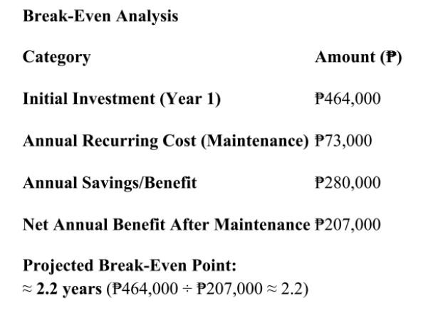
After approximately 2 years, the system will start generating net savings for the university through reduced manual work, time savings, and improved inventory efficiency.
Operational Feasibility
Organizational Structure:
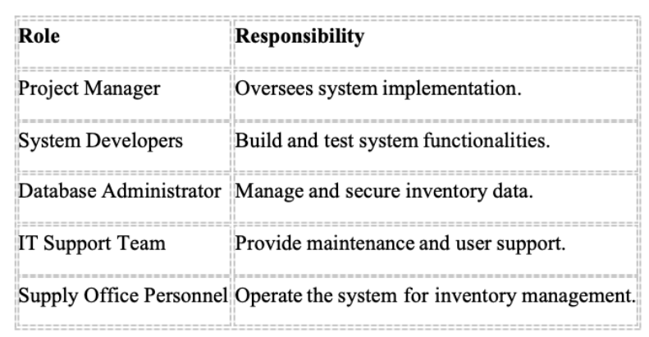
Process Workflows:
1. Faculty submits an online supply or facility
request.
2. Supply staff reviews stock availability and
approves requests.
3. Inventory automatically updates upon
issuance.
4. Admin generates monthly reports for
tracking usage and stock trends.
Risk Assessment:
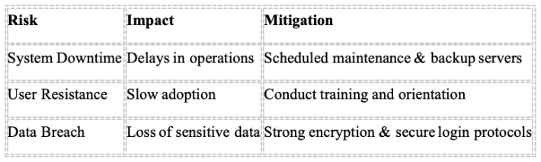Schedule Feasibility
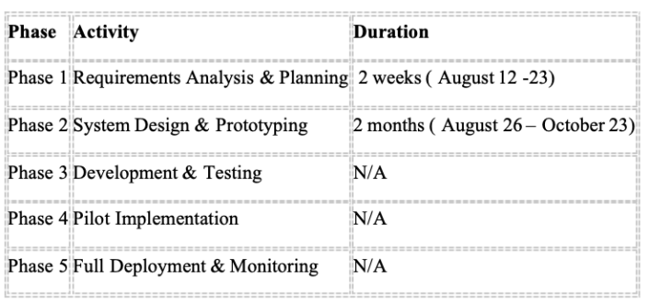
Legal and Regulatory Considerations
· Data Privacy Act of 2012 (RA 10173) – Secure handling of user and inventory data. · Institutional Data Governance Policies – Compliance with PLMun data security protocols. · Accessibility Standards – Ensures usability for all personnel.
· Intellectual Property Rights – Software ownership retained by PLMun.
REQUIREMENTS GATHERING
Methods
· Interviews with Faculty Members: Identify frequently requested supplies (e.g., paper, markers, pens). · Interviews with Supply Staff: Understand workflow bottlenecks and inventory challenges. · Review of Related Systems: Examine best practices from systems like NetSuite or similar inventory platforms. · Online Research: Analyze data on commonly used educational supplies and tools.
_{Hardware Requirements} Software Requirements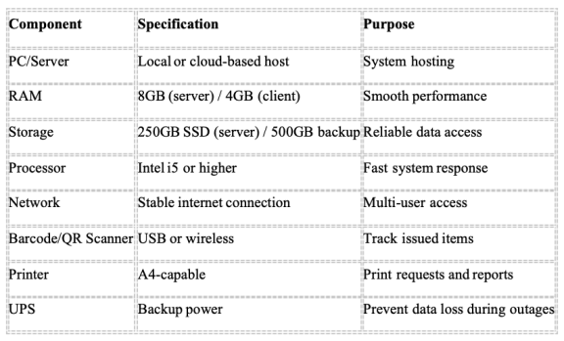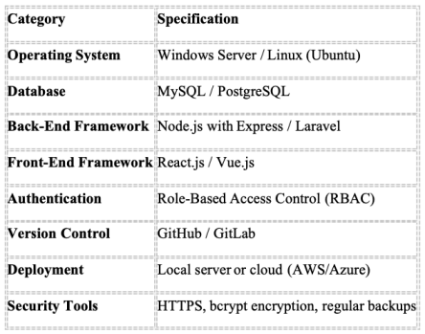
SYSTEM FEATURES
Registration & Login
Functions:
· Account creation using PLMun email.
· Admin approval before activation.
· Role-based access (Admin, Staff, Faculty).
· Duplicate registration prevention.
· Secure login validation with password encryption.
Send Request
Functions:
· Faculty submits supply/facility requests with priority tagging. · Auto-check current stock availability.
· Notifications for request approval or denial.
· Low-stock alerts to admin or supply staff.
Inventory
Functions:
· View and update real-time stock levels. · Add/Edit/Delete inventory items (admin only). · Barcode/QR integration for quick tracking. · Auto-notifications for restock thresholds. · Generate reorder lists and inventory summaries
Reports
Functions:
· Generate monthly or quarterly usage reports. · Analyze item demand by department. · Track fulfillment rates and shortages. · Export reports to PDF or Excel.
· Maintain audit logs for accountabi
Programming Tools PEOPLEWARE REQUIREMENTS
Programming Tools
PEOPLEWARE REQUIREMENTS
DATA FLOW DIAGRAM
FIGURE 2
REFERENCES
Netsuite. (2020, August 26). Must-Have Inventory Management System Features, Requirements & Modules. Netsuite. https://www.netsuite.com/portal/resource/articles/inventory-management/inventory-management-system-features.shtml TeacherLists. (2022-2023).
TeacherLists reports a 32% increase in the cost of the most common supplies requested by teachers and schools on the 2022- 2023 back-to-school school supply lists. TeacherLists. https://www.teacherlists.com/blog/teacherlists-reports-a-32-increase in-the-cost-of-the-most-common-supplies-requested-by-teachers-and-schools-on-the-2022-2023-back-to-school-school supply-lists-mid-season-update/
GROUP 1
ThankYou

